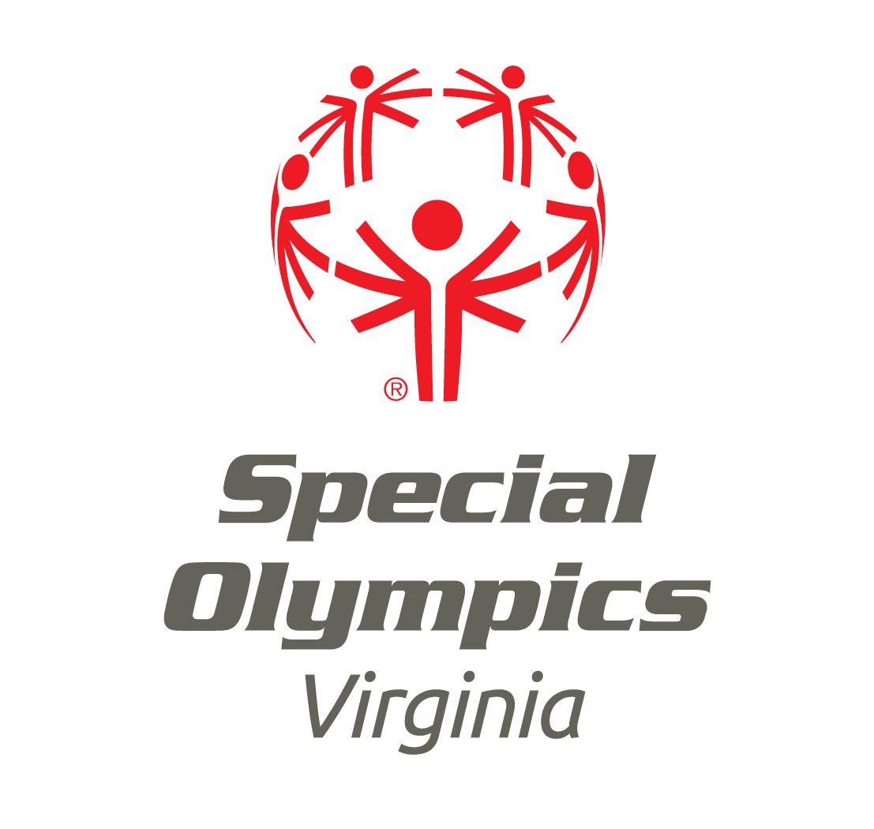
Special Olympics Virginia Policy and Guidelines for Management of Concussion of Special Olympics Athletes

Concussions are a common problem in sports and have the potential for serious complications if not managed correctly. Even what appears to be a minor incident has the real risk of catastrophic results when an athlete is returned to play too soon.

Signs and Symptoms of a Concussion

Symptoms related to brain function:
- Athlete is confused, dazed or has a vacant stare
- Athlete can’t remember things that normally are not a problem for them to remember (i.e. where they are playing, score, name of their team, coach’s name)
- Athlete reports a headache, nausea, vomiting, blurred or double vision, oversensitivity to light or touch, ringing in the ears, feeling tired or dizzy
- Athlete has unusual trouble with focus and attention

Symptoms related to speed of brain function:
- Athlete is slow to respond to questions, has slurred or incoherent speech, or his/her reaction time is slower than normal

Unusual Behaviors:
- Athlete is combative or aggressive
- Athlete exhibits atypical behavior compared to normal
- Athlete asks the same question over and over again
- Athlete becomes irritable or aggressive
- Athlete has inappropriate reactions to situations
- Athlete has trouble finding a comfortable resting position and could be restless

Problems with balance and coordination:
- Athlete is dizzy, slow or clumsy
- Athlete has trouble balancing

Action Plan for Athletes Suspected of Experiencing a Concussion and Return to Play:

- Athletes with a suspected concussion should be removed from play immediately. When in doubt, sit them out. If you are not sure if there is a concussion, remove the athlete from the activity until a thorough evaluation can be conducted.
- Any athlete removed from play because of a suspected concussion must have medical clearance from an appropriate qualified medical professional before he or she can resume practice or competition. Under no circumstances should an athlete with a suspected concussion return to play on the same day of the suspected concussion. Athletes who have been removed for a suspected concussion must sit out for 7 days unless the athlete is evaluated by a medical professional and it is determined that the athlete did not suffer from a concussion or is clear to return to participation.
- Close observation of the athlete should occur for several hours or days depending on the length and severity of symptoms
- The athlete should not participate in strenuous exercise or activity until asymptomatic (free of symptoms of a concussion) and must not participate for 7 consecutive days or until cleared by a medical professional.
- Initial return to play should include non-contact low-impact activity such as walking after 7 consecutive days without symptoms.
- Once low-impact activity can be accomplished without the return of symptoms, the athlete can progress to aerobic activity fundamental to the specific sport (i.e. running, skating)
- Athletes who remain asymptomatic (free of symptoms of concussion) after progressing to aerobic activity can progress into full practice if they have no symptoms, if they have been out for the minimum of 7 consecutive days or they have been cleared by a medical professional to return to activity.
- Athletes who have been evaluated for concussion must return with the Special Olympics Virginia Concussion Clearance Form. This form must be submitted to the Harrisonburg office and be kept with the athlete’s Application for Participation and Release Form.

Required Coaches Training

Required Training and Timeline
All Coaches are required to complete the following concussion awareness training course:

- The Center for Disease Control’s Heads-Up Concussion in Youth Sports course, which is available at http://www.cdc.gov/concussion/HeadsUp/online_training.html. The certificate of completion must be submitted to SOVA.
Beginning January 1, 2015 all new coaches must take concussion training as part of their Class A Volunteer eligibility process. All current coaches must complete concussion training by December 31, 2015.

Volunteers who take the Center for Disease Control (CDC) training must send a copy of their course completion certificate either by email to volunteers@specialolympicsva.org, by mail to Volunteer Manager, SOVA, 3212 Skipwith Rd., Suite 100, Richmond, VA 23294 or by fax to 804-346-9633.

Frequency of Training
Concussion awareness training must be completed by all coaches once every three years.

Communication with Parents and Guardians
Special Olympics Virginia is required to communicate in writing to all participants and/or parents/guardians the existence of a concussion awareness and safety recognition program. This information will be included in the updated Athlete Release Form to be released sometime in 2015. The policy will also be available on Special Olympics Virginia’s website.

The Centers for Disease Control website http://www.cdc.gov/concussion/headsup/ provides additional resources relative to concussions that may be of interest to participants and their families.

Frequently Asked Questions

- Who is considered a “qualified” medical professional?
- The definition of “qualified” medical professional varies by state. In Virginia a qualified medical professional is a physician, athletic trainer or other medical professional with appropriate traumatic brain injury training.

- How should parents/guardians be notified of a suspected concussion?
  - The Center for Disease Control’s website includes several tools that can be provided to parents/guardians of a participant with a suspected concussion. It will also be important to share with the parent/guardian next steps relative to the participant’s return to play, as outlined in the policy.

- Why are coaches for non-contact sports required to complete concussion awareness training?
  - Although concussions may be more likely to occur in contact sports, concussions can occur as a result of any organized or unorganized recreational activity and, therefore, it is important that all coaches participate in concussion awareness training.

- Why do Special Olympics’ return to play requirements as outlined in the Concussion Awareness and Safety Recognition Policy differ from the guidelines provided via the concussion training courses?
  - The return to play guidelines described in some of the concussion training courses require gradually re-introducing strenuous physical activity over the course of several training sessions for those who have suffered concussions. Because Special Olympics’ practices/activities do not occur on a daily basis as is often the case for interscholastic sports training, a similar type of return to play could be difficult to administer and could require a long period of time before an athlete is able to fully participate in Special Olympics activities.

- There are multiple CDC Head’s Up trainings. Which CDC Head’s Up training should Special Olympics coaches take?
- The policy requires the Heads-Up Concussion in Youth Sports training course, which is available at http://www.cdc.gov/concussion/HeadsUp/online_training.html. The CDC website includes other resources/tools for parents, clinicians and school staff that can be used as needed.

- Why are coaches required to complete the training only once every 3 years?
  - Programs may require coaches to complete the training more frequently. However, the 3-year cycle was chosen to coincide with the Class A eligibility requirements.

- Does the Concussion Awareness and Safety Recognition Policy apply to Unified Partners?
  - Yes. Unified Partners who are suspected of having a concussion are subject to the return to play guidelines as outlined in the policy.

Required Clearance Form for Athletes who have a Suspected Concussion

If an athlete is sent for clearance from a medical professional, the athlete must return with the “Concussion Clearance Form” filled out and signed by a medical professional.

A Copy of the “Concussion Clearance Form” should be kept by the local program and a copy must be submitted to SOVA’s Harrisonburg office to be kept with the Athlete’s Participation and Release Forms. Submit all Concussion Clearance Forms to:

Jennifer Gordon at jgordon@specialolympicsva.org or fax to 540-434-6508 or mail to:

Special Olympics Virginia
21 Southgate Ct., Suite 103
Harrisonburg, VA 22801

Special Olympics Virginia Concussion Clearance Form
Name:
Date of Injury:
Today’s Date:

The above named athlete has sustained a concussion. This form is to guide the approved licensed healthcare provider in assessing the athlete’s readiness to initiate a gradual return to participation.

Elements of care include: Athletes should not return to practice or play the same day as the suspected concussion. Athlete should not return to play if they continue to have symptoms of the concussion. Accommodations should be made both physically and cognitively for athletes experiencing symptoms of a concussion.

No athlete is to be permitted to return to participation until all of the following elements apply: (check all that apply and do not return to participation if all are not back to normal/baseline for that athlete)

 | 1. | No symptoms at rest or with normal activities of daily living
 | 2. | Normal neurologic exam
 | 3. | Normal balance and coordination
 | 4. | A return to baseline or normal cognitive testing

Recommendations: (Please check)

 | 1. | The athlete is asymptomatic (no symptoms of concussion) and has passed all of the above evaluations and may return to full participation
 | 2. | The athlete is still symptomatic and not cleared for practice or competition at this time

Please follow these accommodations (list only if accommodations are necessary):

I certify that I am an appropriate licensed healthcare professional permitted to manage concussions per Virginia statue and I am aware of the current recommendations for concussion evaluation and management.
Medical provider name (please print):
Office Street Address:
City: | State: Virginia | Zip Code:
Phone Numbers
Signature:

Please forward a copy of this form to Jennifer Gordon at jgordon@specialolympicsva.org or send to 21 Southgate Ct., Suite 103, Harrisonburg, VA 22801. Fax #: 540-434-6508. The Concussion Clearance Form will become a part of the athlete’s permanent record with their Application for Participation and Release Forms.

